Azure Data Engineer: Batch 6

(October 2023)

**Submitted by: Roopmathi Gunna**

# **Assignment 6:** ADF Pipeline 3

Easy Questions:

1. Create a pipeline name 'Without_Foreach_Example' to copy the Customer & Customer address table data into ADLS without using foreach activity.

Here is a Data Pipeline created with two Copy Activities in succession without using the “Foreach” example

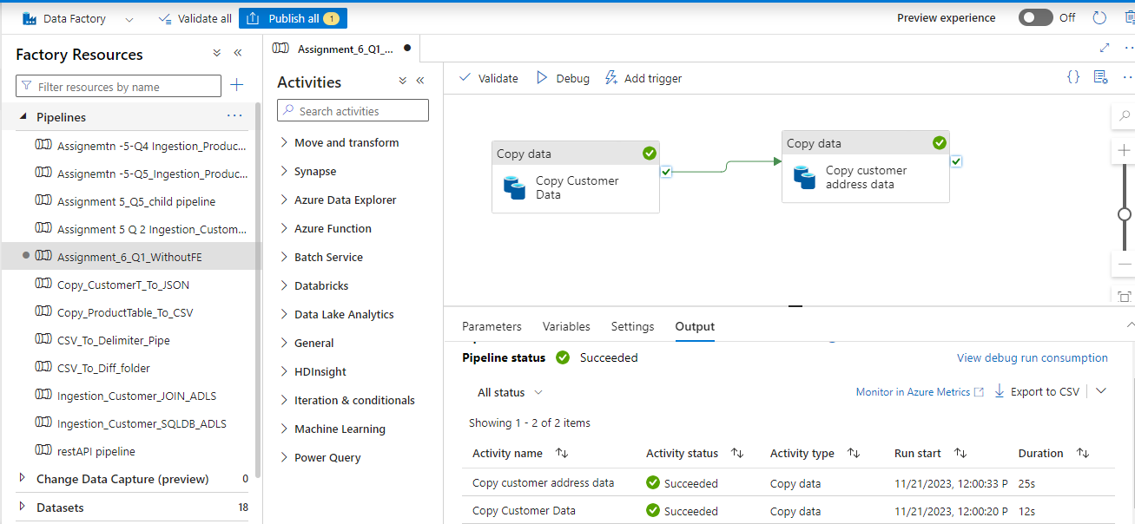

Here is the Source settings :

Here is the Sink Settings:

Now let us validate the data is copied in ADLS: Customer Address table is copied.

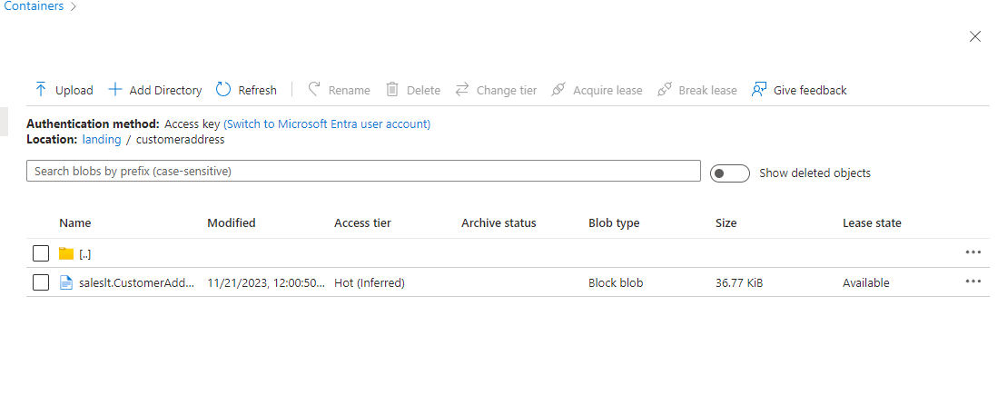

Customer table copied into Customer Detail folder as specified in Sink settings:

2. Create a pipeline name 'Foreach_Example' to copy the Customer & Customer address table data into ADLS using the one copy activity.

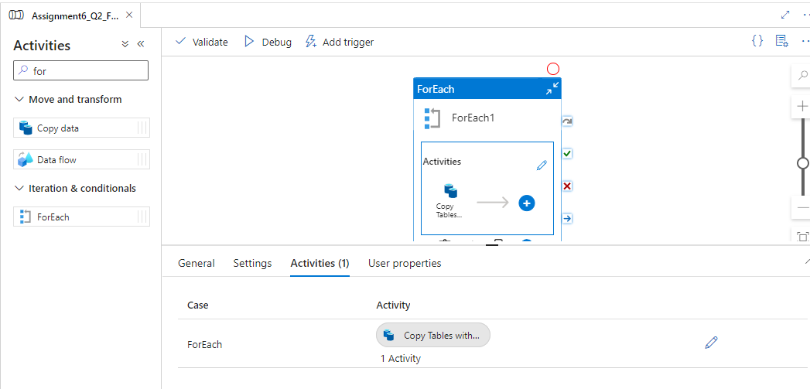

Sink Set-up looks like this:

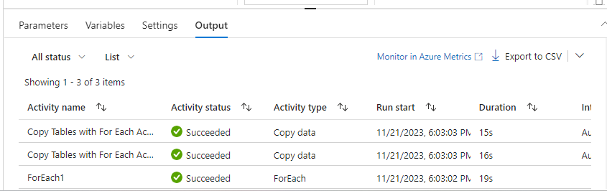

Tricky Questions:

3. Create a pipeline name 'Foreach_Example_2' which solves the following business use case.

Customer data is very important for our business. Hence whenever we have more than 100 records in the customer table,we copy the customer data to another table customer_copy within the sql db.

However whenever we do this copy, we first truncate the table 'customer_copy' and then copy the data from 'customer' table. Hint : Use ADF to solve this problem.

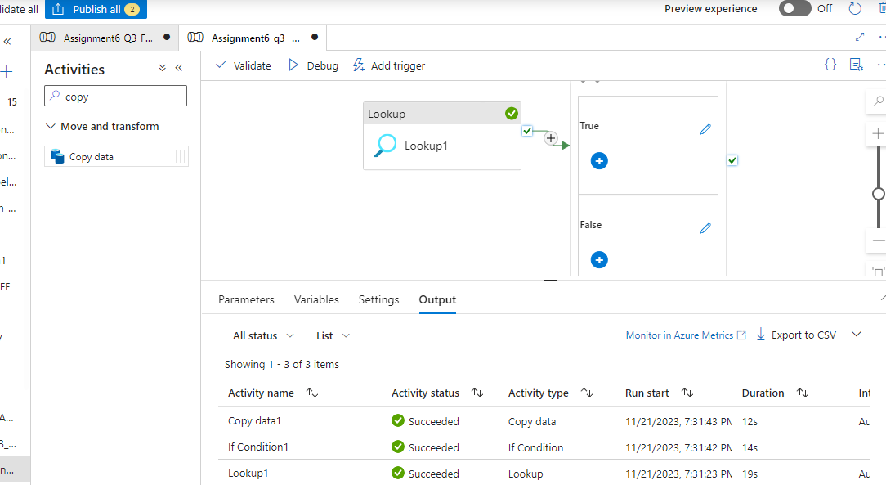

4. The business wants to move the data from 3 different tables (Customer, Product, CustomerAddress) to the ADLS location in CSV format. However, they want the make a pipeline in such a manner that All these copy happens through an individual pipeline, which is called by one common pipeline.

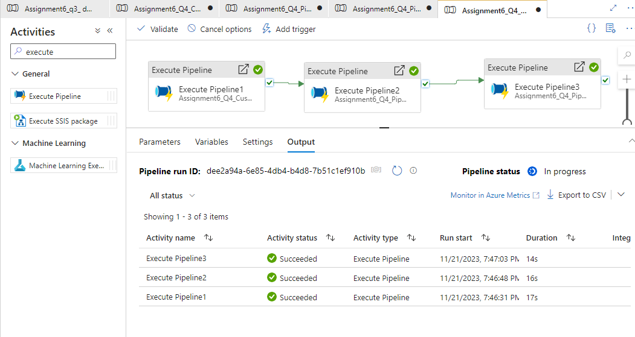

5. In the above case, the problem is that every time the pipeline runs it will overwrite the data. Ensure that all the data goes into the Folder in this format: (Customer/Year/Month/Day) to avoid any overwriting. Please rewrite the pipeline.

6. I am attaching a file, load this file into your ADLS location. This file contains a threshold value. Create a pipeline in such a manner that, it will first get the threshold value from this file and then check if the record count in the customer table is more than it or not.

If yes then copy the customer data from SQL db to ADLS location in JSON format.

